**Team “Kung Lao”**

1. Alexander Ignatov (alboig)
2. Alexander Pavlov( Alexio86)
3. Damyan Besheliev (besho14)
4. Dimo Petrov (dimo.petrof)
5. Kiril Lyomchev (KirilLyomchev)
6. Kiril Stoyanov (kiril_vs)
7. Martin Shoilev (martin.shoilev)
8. Plamen Stepanyan (Flame78)
9. Hristo Stoichev (hristostoichev)

# Project Description

Tetris or Tetriminos is game pieces shaped like Tetriminos, geometric shapes composed of four square blocks each. A random sequence of Tetriminos fall down the playing field (a rectangular vertical shaft, called the "well" or "matrix"). The objective of the game is to manipulate these Tetriminos, by moving each one sideways and rotating it by 90 degree units, with the aim of creating a horizontal line of ten blocks without gaps. When such a line is created, it disappears, and any block above the deleted line will fall. When a certain number of lines are cleared, the game enters a new level. As the game progresses, each level causes the Tetriminos to fall faster, and the game ends when the stack of Tetriminos reaches the top of the playing field and no new Tetriminos are able to enter.

Gameplay:  
Before starting the game the user sees information with the controls:

* Move left
* Move right
* Drop block
* Push down
* Rotate

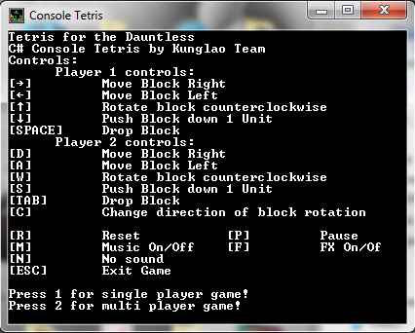

The user can choose between single and multiplayer.  
After starting the game on the right side of the field the user has a help menu and information about the current result, level, lines and a smaller window with information about the next block.

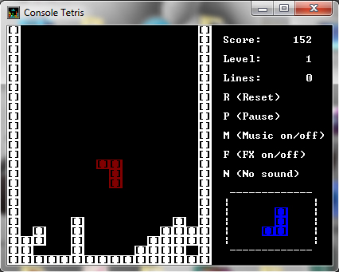

The project satisfies completely the general requirements of the assignment.

It has the following elements:

1. **Classes**:

* ***Blocks:*** Create blocks, block rotate, set color, connects blocks using operator + , overlap blocks, print blocks
* ***ConsoleTetris***: Restart game, game over, keyboard reading, random generate blocks,
* ***Sounds***: Music on, Music off, play sounds from file, play sounds from a text (music.mus) file using Console.Beep().

Required Classes: 0, Classes in app: 3

1. **Methods**:

* ***ResetTetris***
* **PrintStatus**
* ***PrintOnPosition***
* ***Left***
* ***Right***
* ***Down***
* ***Drop***
* ***Rotate***
* ***Gameover***
* ***PrintMenu***
* ***KeyboardReading***
* ***Delay***
* ***GenerateRandomBlock***
* ***PrintNextBrick***
* ***CheckForCompleteLines***
* ***ClearRow***
* ***Block***
* ***SetColor***
* ***Move***
* ***OverlapBlocks***
* ***Print***
* ***MusicOn***
* ***Sounds***
* ***ChangePlayerDirection***
* ***PlaySoundFromFile***
* ***ConsoleBuffer***
* ***StopMusic***
* ***StartMusic***

Required Methods: 10, Methods in app: 28

1. **Exceptions**:

* **TypeInitializationException**
* **ArgumentNullException**
* **ArgumentException**
* **FileNotFoundException**
* **FileLoadException**
* **IOException**
* **UnauthorizedAccessException**
* **SecurityException**

Exceptions: 2, Exception in app:8

1. **Multi-dimensional arrays:**

* ***In Sound***
* ***In Blocks***
* ***In Rotate Method***
* ***In new block creation***

Required Multi-dimensional arrays: 1, Multi-dimensional arrays in app: 4

1. **One-dimensional arrays:**

* ***PlayerPos – set player position;***
* ***randomColor – generate random color;***
* ***Block – Create new blocks;***
* ***brickPlayer – array to hold the bricks of both players***

Required One-dimensional arrays: 3, One-dimensional arrays in app: 3

1. **Existing .NET Classes**

* ***System.Console***
* ***System.ConsoleColor***
* ***System.Random***
* ***System.Threading.Thread***
* ***System.IO.StreamReader***
* ***System.SoundPlayer***

Required Existing .NET classes: 3, Existing .NET classes in app: 6

1. **External file use:**

* 6 files used for the sound and 1 for music

Required External file: 1, External files in app: 7

1. **Sound effects**

* Sound when Clear Line
* Sound when drop block
* Sound for game over
* Sound when players level up
* Sound when move the blocks
* Sound when Rotate blocks

<https://kunglao.codeplex.com/>